<http://localhost:8080/manager/html/undeploy?path=/tasks-0.0.1-SNAPSHOT&org.apache.catalina.filters.CSRF_NONCE=C03A83BD35BD9B45122A78F2E526D075>

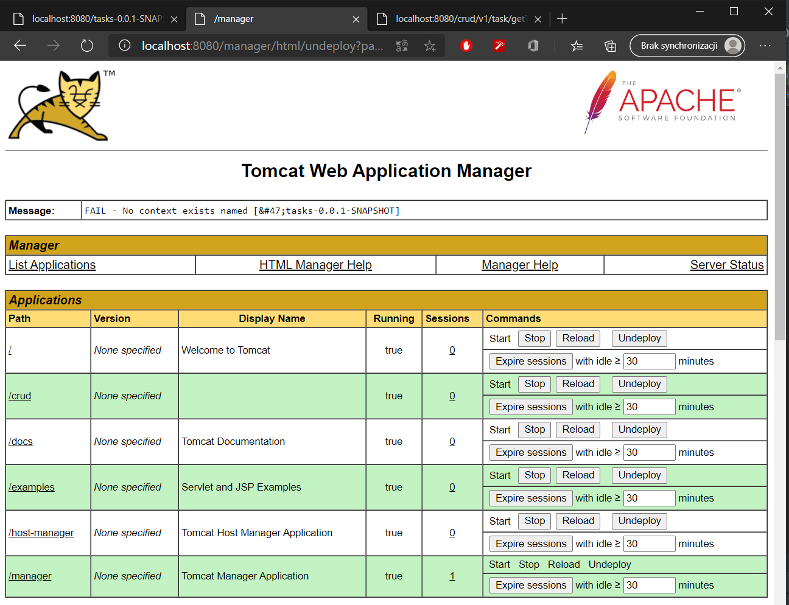

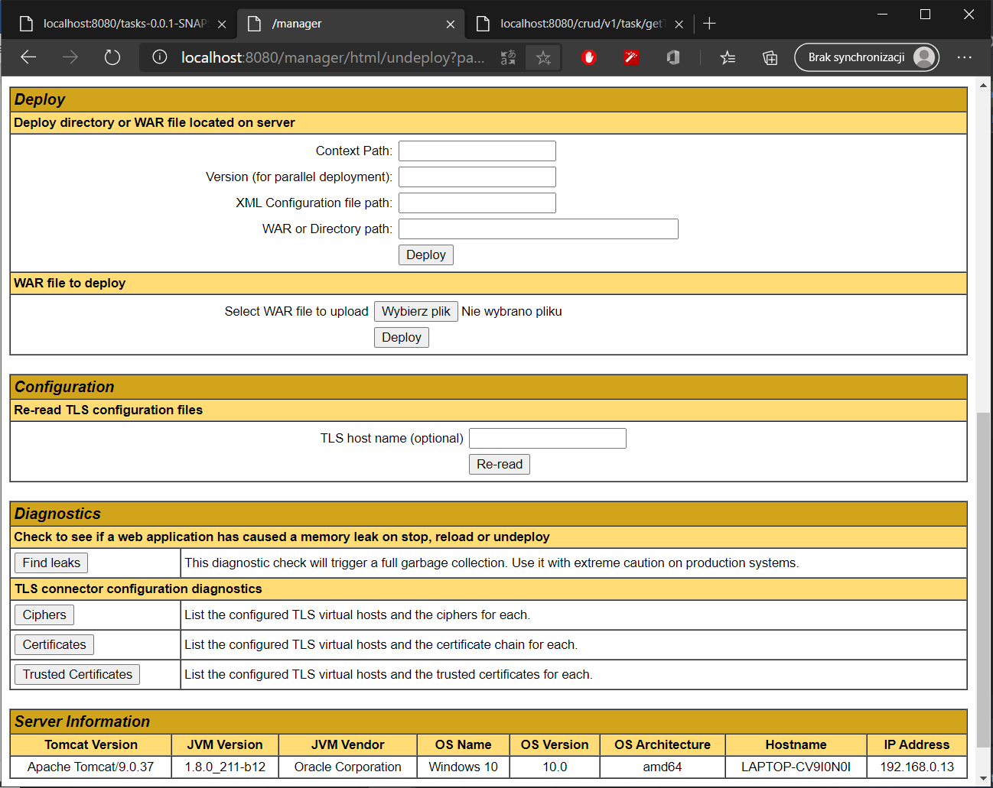



<http://localhost:8080/crud/v1/task/getTasks>

